More Resources for Hosting Online Meetings

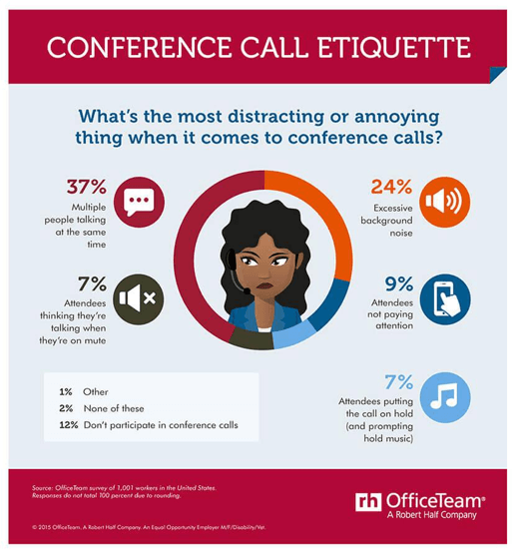
At District 55, we want you to have all the resources and support you need to make your online meetings a big success. We strongly encourage all our Clubs to host their meetings online and invite other Clubs and non-members to visit by sharing their links on social media and with the District.

To get started, here are some platforms to consider:

GoToMeeting
Free Conference Call
Zoom

Google Hangouts

Webex
Skype (for Business, link created by a member)
eyeson (visit Tri-Counties meetings on Monday nights to see what this platform is like)

Platforms Comparison

How to Host Successful Online Meetings- Best Practices

16 Secrets to Keep your Remote Team Engaged on Meetings

Home Internet Jammed Up? Try These Steps Before Upgrading

Zoom Troubleshooting
Test Your System Compatibility
Common Issues
My audio/video is choppy, laggy, or stops.
- Shut down any background apps, especially Outlook.
- If step 1 doesn’t help:
- Try refreshing browser page if using the web app
- Move to phone audio
- It could be your internet speed. Try a speed test.
- For stable audio/video quality you should have a download speed of at least 10Mbps

I can’t hear anything
Check your audio source in the Zoom app. For Computer Audio:
- Ensure that your computer speakers are on and unmuted
- Ensure that the audio source in zoom and the audio source in your system settings are the same
- If you are unable to establish an audio connect, try using phone audio instead.

My microphone is muted.
This is normal. The program defaults to muted when attendees join the session, or the presenter may have muted all attendees. If they wish to call on you, they will unmute you.
Note: Muting the microphone does not impact the audio you receive from the presenter or other participants.

Where do I find the materials for this event?
Materials are found in the chat section. Try scrolling to the top of the chat.

Have an issue that wasn’t listed here? Check Zoom’s Help Center.

Courtesy of Skilpath.com

Please let us know the following:
If you would like to share your experience, skills or best practices on platforms other than Zoom.

If you Club is holding virtual meetings and open to visitors, please share your link with us, so we can post it online.

Please contact us at d55dd@tmd55.org if we can be of assistance.

Please join us at and let’s stay connected:
Facebook Group Page
LinkedIn Group Page

